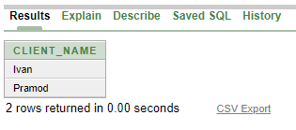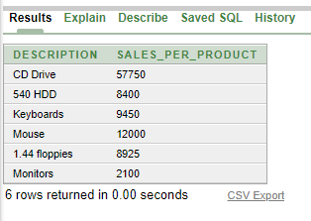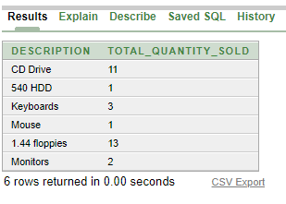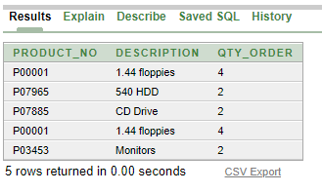

|  |  |  |
| --- | --- | --- |
| **PRODUCTNO** | **DESCRIPTION** | **QTY** **ORDER** |
| P00001 | 1.44 floppies | 4 |
| P00001 | 1.44 floppies | 2 |
| P00001 | 1.44 floppies | 2 |
| P00001 | 1.44 floppies | 10 |
| P00001 | 1.44 floppies | 3 |
| P00001 | 1.44 floppies | 10 |
| P00001 | 1.44 floppies | 4 |
| P00001 | 1.44 floppies | 2 |
| P00001 | 1.44 floppies | 1 |
| P00001 | 1.44 floppies | 1 |
| More than 10 rows | available.Increase rows | selector to view more rows. |